**Name :**

**Hafsa Waseem**

**Roll no:**

**SU92-BSSEM-S24-014**

**Subject :**

**DSA (Lab)**

**Section :**

**3A**

**Submitted to:**

**Sir Rasikh**

**Task no 1 :**

**Implement functions to display the first node, last node, Nth node, and centre node of a singly linked list.**

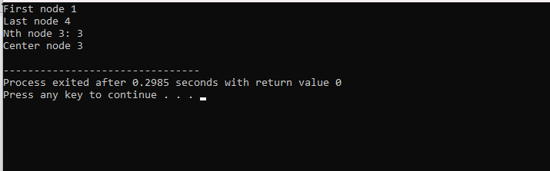

**Explanation :**

In this code , we made a class of node .In this class, has two data attributes and then we made a constructor and the we made a 5 functions (displayfirstnode, displaylastnode ,displaynthnode, displaycentrenode,addnode)In the main functions ,we call all the functions .